
Information Strategy and Services

Accessing CU ChatGPT Edu
Table of Contents
Getting Started 1
Step 1 1
Step 2 2
Step 3 2
Step 4 2
Step 5 3
Step 6 4
Troubleshooting and Tips 6

This guide walks university faculty, staff and students through the complete process for gaining access to CU’s ChatGPT Edu tool. This includes steps from confirming eligibility, to taking the required UIS training, to successfully gaining access and using the tool.

Getting Started
  - Before Starting the Process
Before you begin, make sure you have the following:
- A valid university email address
- Verified eligibility for CU ChatGPT Edu access
- Completion of required UIS training
- Access to your university email inbox

- If you have an existing paid ChatGPT subscription (Go, Plus, Pro, or Business) that is linked to your university-issued email address, it is recommended NOT to join CU’s ChatGPT Edu at this time.
You will lose functionality and will NOT be able to leave the CU instance of ChatGPT Edu after joining.

- If you have an existing free ChatGPT account associated with your university-provided email address and do NOT wish to transfer in your chats, please select the "Export and Delete" migration option, found in the “Migrating an Existing ChatGPT Account” guide.

Step 1
  - Verify Eligibility
The following university community members are eligible for a free CU ChatGPT Edu account are:

Eligible Position | Includes
Faculty | Full- and part-time faculty including: tenure, tenure-track, instructional, research & clinical, instructors, lecturers, postdoctoral associates/ research fellows
University Staff | Full- and part-time staff
Classified Staff | Full- and part-time staff
Students | Actively enrolled, degree-seeking full- and part-time students and student employees starting August 2026.

The following university community members are ineligible:
Persons of interest (POI), contractors, temporary workers, working retirees, emeritus roles, volunteers who are not official employees, unpaid or courtesy academic appointments (e.g., adjunct, visiting, museum-related roles), contract or grant-funded staff paid with external funding, admitted but not enrolled students (including confirmed students who have accepted admission and paid a deposit but are not yet enrolled), active but not enrolled students, alumni, visiting or non-degree/continuing education students, and volunteers or trainees who are not enrolled students.

Step 2
Complete Required UIS Training
- Complete the required UIS training: "Using AI at CU"
- Ensure the training shows as completed before proceeding.
- Provisioning will not continue until training is completed.

Step 3
  - CU ChatGPT Edu Invitation Email
- After you complete the training, wait for an email invitation from OpenAI for CU ChatGPT Edu.
- Go to Step 4 if you have an existing ChatGPT account with your university email BEFORE accepting the invite.
- The invite may take up to 24 hours to arrive in your university email inbox after you have completed the training.

Step 4
  - Existing ChatGPT Account Users
If you do not already have a ChatGPT account with your university email, you can skip this step and go on to Step 5.

Existing Users:
- Follow the instructions in the guide for “Migrating an Existing ChatGPT Account.”
- You have the options to:
  - Transfer existing chat history and custom GPTs into the university's ChatGPT Edu instance.
  - Export and permanently delete existing chat history and custom GPTs.
    - NOTE: While this will export your data to a file for download, there is no way to import this data into a new account.
- After completing migration, return here and continue to Step 5.

Step 5
  - Accept Invitation and Join CU ChatGPT Edu
Still have questions? Contact the Service Desk: call 303.724.4357 (4-HELP from a campus phone) or open a ticket at servicecenter.oit.ucdenver.edu/CherwellPortal.
Updated on: DATE

Cre

You may proceed with this step if:
- You understand that the migration or export process is permanent.
- You understand if you have an existing paid subscription, you will lose premium functionality (premium models, apps, codex, etc.) by accepting this invitation.

If you are ready, or if the above does not apply:
- Click on the "Join workspace" button on the invite email from OpenAI.
- Your account, whether new or existing, will now be in the CU instance of ChatGPT Edu.
- Proceed to Step 6 to sign in.
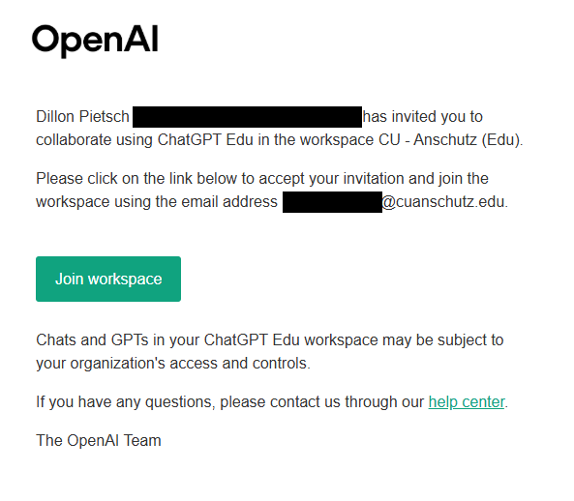

Step 6
  - Signing in to CU ChatGPT Edu
Still have questions? Contact the Service Desk: call 303.724.4357 (4-HELP from a campus phone) or open a ticket at servicecenter.oit.ucdenver.edu/CherwellPortal.
Updated on: DATE

Cre

- After accepting the invitation, you will be redirected to OpenAI where you will see that you have been added to either the CU – Denver (Edu) or CU – Anschutz (Edu) workspace. Click the button to “Log in.” 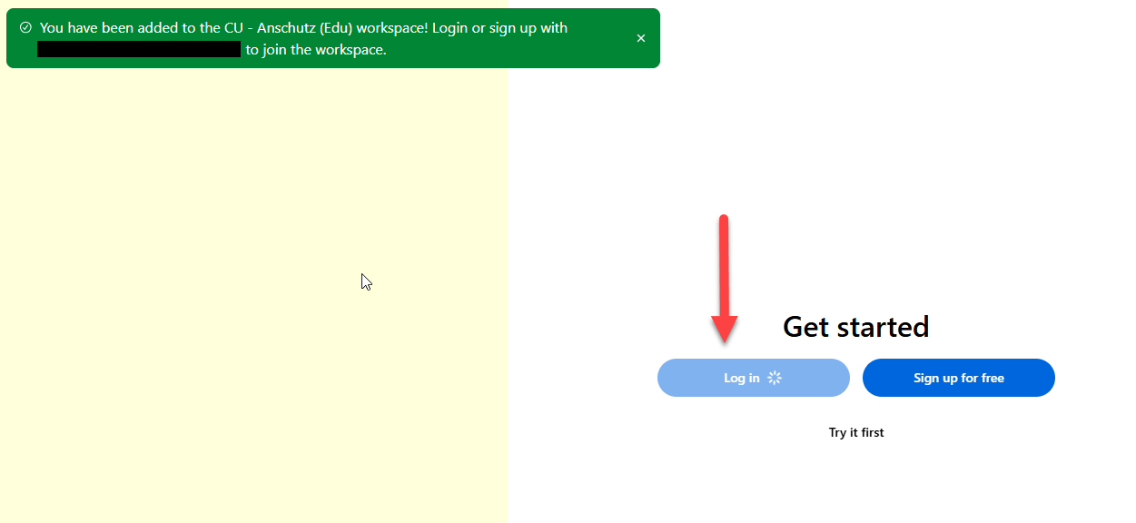

- You will be taken to a login screen. Choose the “Email address” option and sign in using your university email (@ucdenver.edu or @cuanschutz.edu).
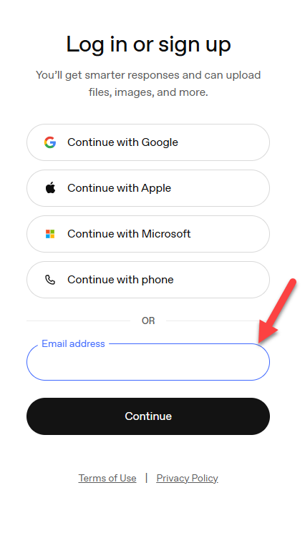
- After you enter your university email, you will be redirected to the CU “Web login” portal. Enter your university credentials and verify Multi-Factor Authentication (MFA).
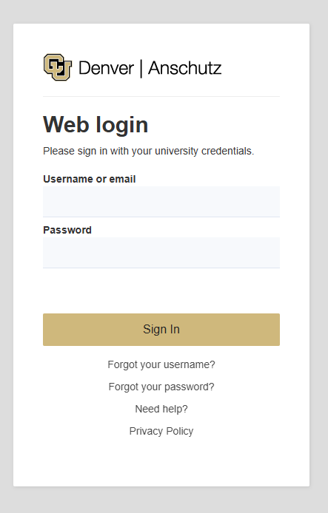
- After signing in, you may see a screen asking you to "Verify it's you."
  - Verify your email address to ensure it matches with your account.
  - Click the "Approve sign-in" button to continue if it matches.
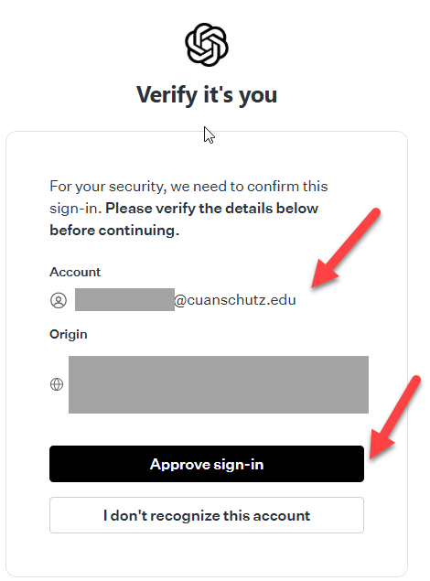
You can now use CU ChatGPT Edu.
You can verify you have successfully accessed the CU instance of ChatGPT Edu by looking for "CU - Denver (Edu)" or "CU - Anschutz (Edu)" in the lower left-hand corner:
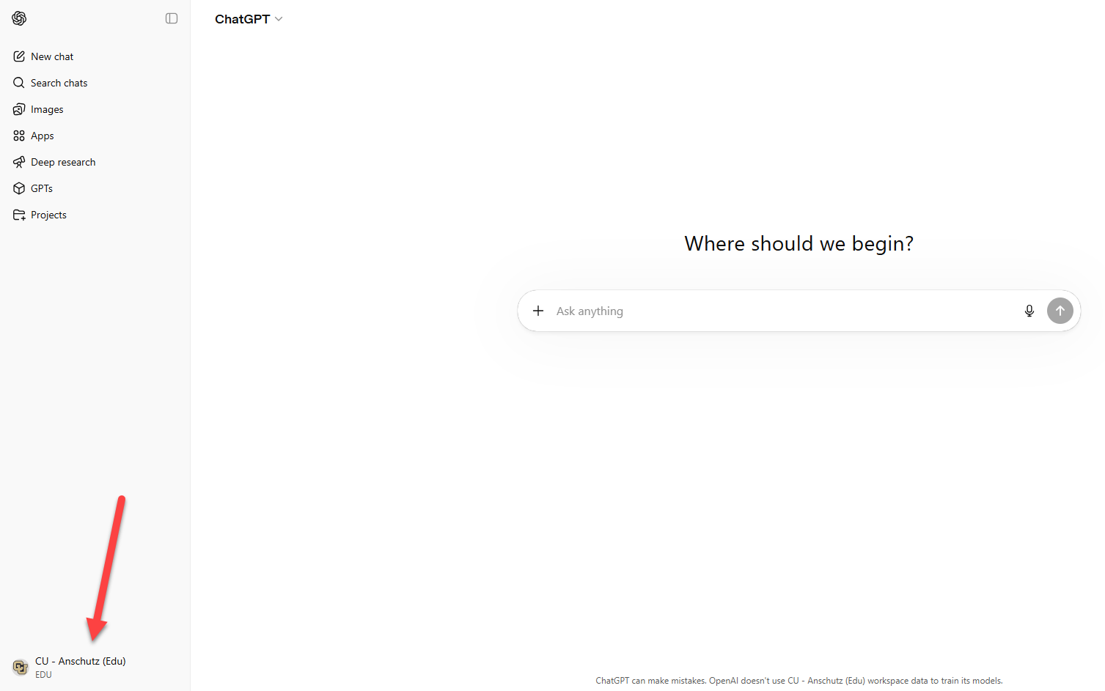

Troubleshooting and Tips
  - If You Are Having Issues Loging In
- I haven’t received an invitation after 24 hours.
  - Sign into the portal to trigger the provisioning process again.
  - Confirm that your UIS training shows as completed.
  - Check your spam or junk folders.
- I accepted the invitation before I was ready to migrate.
  - If you accept the invitation without completing migration or preparation, contact the Service Desk (303-724-4357) for assistance.
- I can’t join the CU ChatGPT Edu instance.
  - Ensure you are signing in with your university email.
  - Confirm you meet eligibility requirements.
  - If issues persist, contact the Service Desk for support (303-724-4357 or oit-servicedesk@cuanschutz.edu)

