
Information Strategy and Services

Duo: New Phone, Same Number 2026
Table of Contents
New Process as of April 2026 1
New Phone with Duo 1

New Process as of April 2026
  - Logging into a Secure Resource
Duo is the tool used for Multi-Factor Authentication (MFA) across the university. The application has been updated to a newer version with enhanced security, which has resulted in some changes to the verification experience when using Duo for MFA.

New Phone with Duo
  - Updating Duo with a New Phone
Still have questions? Contact the Service Desk: call 303.724.4357 (4-HELP from a campus phone) or open a ticket at servicecenter.oit.ucdenver.edu/CherwellPortal.
Updated on: DATE

Cre

If you have gotten a new phone and have the same phone number, you will follow this process to install Multi-Factor Authentication (MFA) with Duo so that you can continue to access secure university resources.

Step 1: Login to a secure resource with your university credentials when prompted.
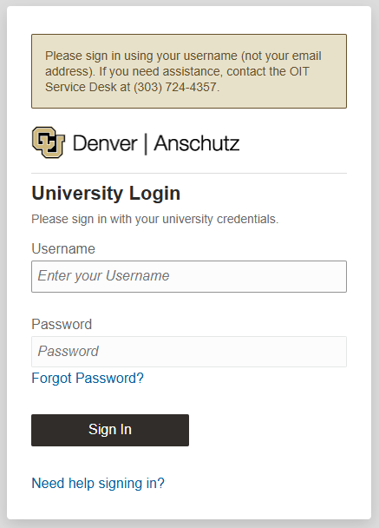

Step 2: After entering your credentials, you will be directed to a Duo screen with your username in the upper left corner prompting you to “Verify” that you are logging in.
Click the black “Verify” button to proceed if your username and log in attempt match.
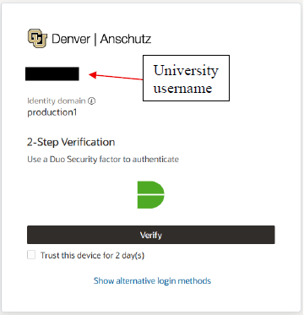

Note: If you are on a secure and trusted device, such as your university-provided computer for faculty and staff, or a secure personal device for students, you can choose to “Trust this device for 2 day(s).” This will allow you to remain verified and skip the MFA step when logging into university resources for two days. This option may change based on a user's risk profile.

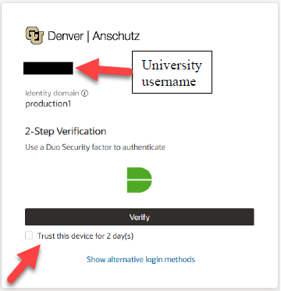

Step 3: The Duo authentication screen loads, select “Send Me a Push” and it will send a prompt to your old device that is no longer accessible. This is intentional, proceed to Step 4.

Note: Push verification is the most secure method of MFA verification as calls and passcodes are more susceptible to phishing.
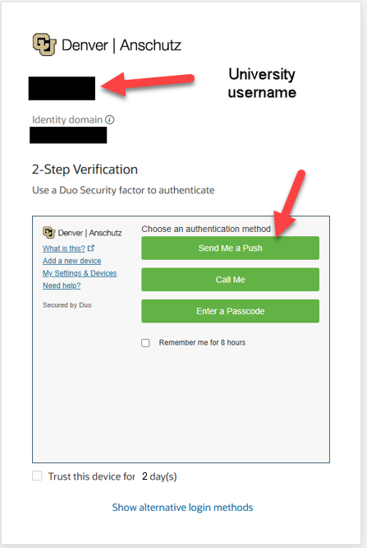

Step 4: Allow the Push request to time out. When the request times out, you will receive a new screen with the option to “Try again” or “I got a new phone.”

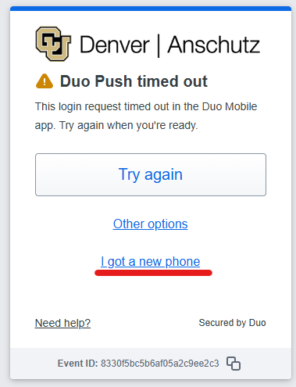
Step 5: After you select “I got a new phone” a screen will pop up asking if you have the same phone number. It will display the last four digits for you to confirm the phone number connected to your Duo account.

If it is correct, click the button to “Text me a link.”

If the phone number does NOT match, stop and contact the Service Desk for assistance.

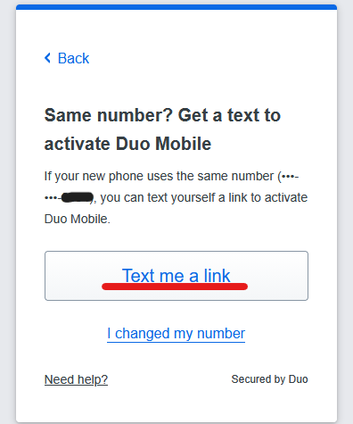

Note: The option “I changed my number” will not work unless you still have access to the old device. If you have a new phone and a new phone number, please contact the Service Desk for assistance.
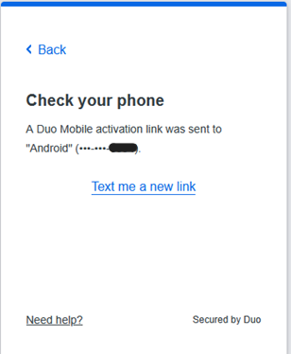
Step 6: You will receive a text message from Duo with a link to activate Duo Mobile on your new phone.

Note: You need to have the Duo Mobile App installed on your new phone before clicking this link to set it up.

Step 7: After completing the setup process within the Duo Mobile App, you now continue to access secure university resources as normal.

If you were unable to complete this process as expected, or if you encountered additional issues, please contact the Service Desk via phone 303-724-4357:
- Monday to Thursday: 7:30 AM - 6:00 PM
- Fridays: 7:30 AM - 5:00 PM

To protect your identity, data and maintain information security, additional verification will be required. To help the Service Desk assist you efficiently, please ensure that you have a valid photo ID (State ID, Passport, Driver’s License, or university badge) ready, and that your Zoom application is open and up to date before calling.

