Financing Vitality Instead of Sick Care and Social Failure
David Aylward, Senior Advisor, Farley Health Policy Center; Assistant Clinical Professor, Department of Family Medicine, University of Colorado School of Medicine, June 2023

American healthcare and people investment is upside down. Our population would be healthier with less overall health spending if we increased investment in next generation primary care integrated with appropriate social service interventions, instead of our predominant (87-91%) health spending on specialists and acute care. Extraordinary profits are being made in the US by monetizing sickness. This paper suggests how to increase health, especially for the most marginalized, for less than the 18% of GDP that we pay for health today (much less for other social failures, e.g., corrections). This would save money for everyone who pays “social failure” bills, starting with Medicare and Medicaid, and including child welfare, courts), and producing other major benefits for society, such as better students and more productive workers. The paper addresses the primary barriers to longer term investment in people (e.g., “wrong pocket”, need for “braiding and blending”, need for short term return on investment (ROI), and proposes a way for investors to profit from getting people healthy, particularly the poor.
Medicine Alone is NOT Health
Health is produced by far more than just medicine. In addition to genetics and medicine, a series of environmental, social, and personal influencers (the “social determinants of health” or SDoH) play critical roles in producing either vitality or illness. This chart shows the combination of health drivers.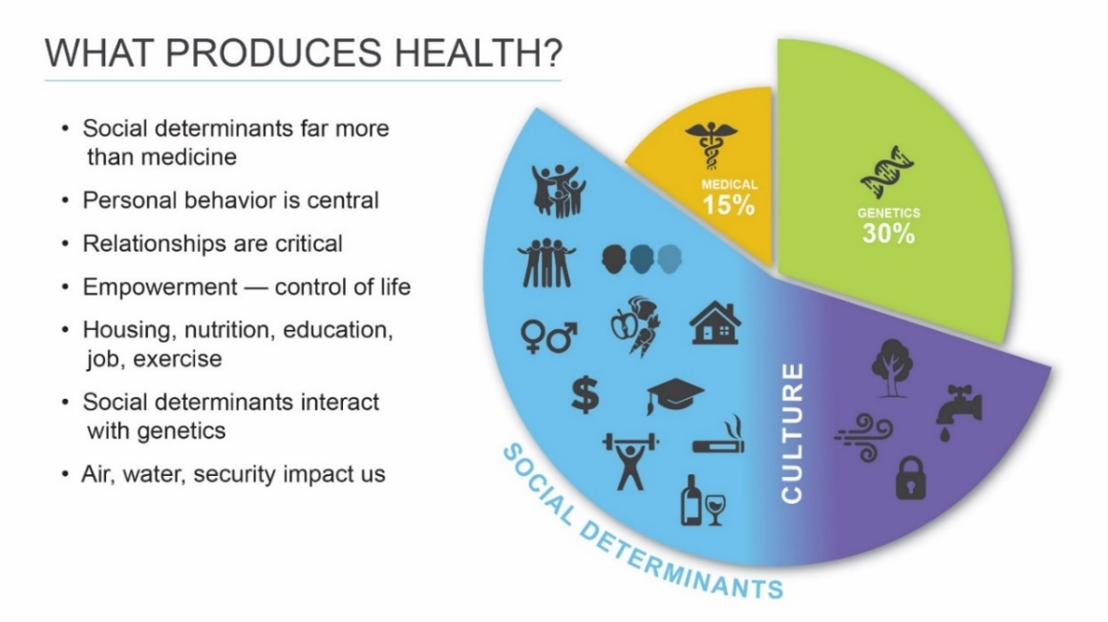
Our current health system has this backwards, however. We spend most of our health money on an industrial strength “repair system” which only goes into high gear when people get seriously sick. Most health experts agree that investing more in primary care and “upstream” in SDoH will produce both better health outcomes and lower costs. This is also true in social services fields, where we spend far more on corrections/jail later in life but choose not to invest much early. The metaphorical “Story of the River” is often used to describe this problem. The story describes some people on the riverbank focused on saving people just before they go over a waterfall to their deaths -- rather than going upriver to see why they are falling into the river in the first place. The story is shown in Figure 2, comparing Upstream (“prevention”) and Downstream (“sick care”) health investing.
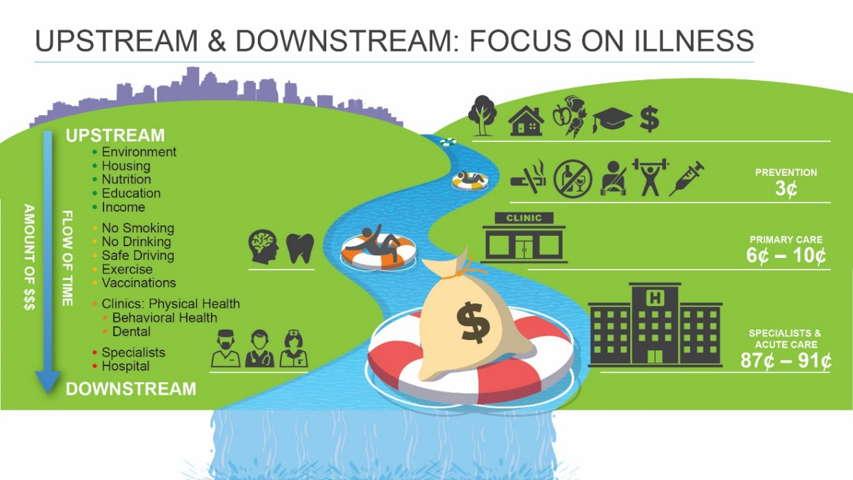
Figure 2.
Notice that in health we focus our attention and funding to keep people from “going over the falls”, using specialists and acute care resources to keep them from dying, instead of keeping them out of the river to begin with using upstream investments in social determinants and primary care. Efforts at health cost control today seldom go far up the river, do not change the systemic financial incentives, usually have a short time horizon for required return on investment (ROI), and savings from prevention are typically only offered to medical organizations, which can only impact a slice of health.
So why have we not yet seen a flipping, a reversal, of investment? In short, it requires a fundamental redesign of the health system with a new goal of vitality/thriving instead of monetizing sick care and social failure. This requires a new business model that rewards providers/investors for producing those new thriving outcomes. There are major challenges that must be solved to create that new business model: (1) three critical financial mismatches and (2) one big data gap.
But first, a story.
Denver had a serious problem with a subset of its homeless population. Each year, 250 chronically homeless individuals accounted for 14,000 days in jail, 2,200 visits to detoxification, 1,500 arrests, and 500 emergency room visits. These people had significant behavioral health issues. Each year, the average cost to local taxpayers per homeless individual for these services was $29,000. So Denver spent approximately $7 million annually to cover these expenses from the 250 individuals.
Some smart local leaders said: “There must be a better way.” The solution proposed was “permanent supportive housing”, housing especially designed (“trauma informed”) for people who have suffered innumerable traumas, along with an array of supporting behavioral and other health services. If these people received appropriate housing and treatment, advocates argued, there would be major savings in Denver’s budget, and in many other state and federal programs, such as the large amounts that Medicaid was paying for repeated emergency room visits and other acute healthcare.
However, the costs of building apartments and providing comprehensive support services were substantial. The savings were not certain; they would be produced over time, not immediately. The Denver jail system is not in the business of creating permanent supportive housing; and the not-for-profit organizations in Denver that create affordable housing and provide supporting health services (1) were not investors; they lacked capital, and (2) could spend a lot of money building housing and taking care of these people, but would get none of the potential savings, even if they were 100 percent successful (this is frequently called the “wrong pocket” problem).
THAT is a complicated, “wicked” social problem.
A group of public, civil society, and private organizations solved the problem with a display of remarkably thoughtful civic leadership and cooperation. They developed and implemented a “pay for success” solution. Think of it as a three-legged stool built to serve these marginalized people, improving their lives, and making the streets safer for less overall cost to society than leaving these people to suffer. Leg 1 of the stool represents the service providers (housing, behavioral health, and related services). Leg 2 represents the budget beneficiaries if the project succeeded (the City and County of Denver; potentially Medicaid). Leg 3 are the risk-taking financiers (a collection of commercial lenders and foundations investing and sharing the financial risk).
How did the project work? Leg 3 provided the risk investment (through a “social impact bond”) to Leg 1 to build the apartments and provide behavioral health and other supporting services to the formerly homeless residents over time. Leg 3 is being repaid with interest by Leg 2, if and to the extent that the promised savings are achieved.
In 2021 the Colorado Sun reported: “After the program met its goals, the city paid investors $9.6 million — $4.5 million in housing stability payments, $5.1 million in jail diversionary payments, plus $1 million for the project’s success. Investors agreed to share a portion of the $1 million payment with the two main service providers: The Colorado Coalition for the Homeless and Mental Health Center of Denver.” “The program was so successful at keeping people in stable housing and out of jail, that the U.S. Treasury Department has offered the city more than $6 million in new federal aid, if the program can demonstrate a comparable drop in Medicare and Medicaid billings over the next seven years.”
Note the critical new addition of Leg 3: investors in a thriving outcome.
Yes, the Denver project addresses only a slice of the much more complicated overall health industry, but it teaches critical lessons by solving the same three major financial challenges/mismatches that we face as we seek to transform the health system.
What happens if we design a more comprehensive approach? Marginalized people would be much healthier in general if they were provided with an integrated combination of person-centered primary clinical care and social services individually designed with them to meet their overall needs (both individual and family). These personal success programs would be delivered over time through collaborative systems explicitly designed to produce vitality, to meet new “thriving” metrics, rather than to repair sick people, as shown in Figure 3, below.
There is strong support in the literature that investing in primary care (“midstream”) and in social supports “upstream” in this fashion will produce significantly healthier people while reducing overall health expenditures. That evidence is based primarily on individual interventions expected to have short term effects, not comprehensive, holistic, and longer-term programs such as those discussed here. Thus, we can reasonably expect the comprehensive impact to be larger.
Federal and state leaders of Medicare and Medicaid clearly understand the power of social determinants to affect health quality and costs. The last few years have seen them actively encouraging clinical providers to coordinate with community benefit organizations (CBOs), loosening the rules to allow the use of Medicare and Medicaid funds for some social determinants (either directly or as part of a package), funding medical/social service coordination infrastructure, and approving Section 1115 waivers for some states that include some investment of Medicaid funds in Accountable Communities of Health which invest directly in some SDoH (on a community level, not in a coordinated way for specific families integrated with clinical services as suggested here). CMMI has funded over 20 significant trials of systems with “backbone organizations” that more closely link clinical and social service providers, albeit still on a transaction-by-transaction referral basis instead of a comprehensive, personalized program implemented over time. In 2020 CMMI awarded eight Medicaid contracts pursuant to a new RFP for the whole person care of children (“InCK”, described in footnote 9) that addresses the importance of social determinants. Those are seeking to provide longitudinal, wraparound, comprehensive care coordination for high-risk children beginning this year.
So how could we organize this to have maximum impact? Let’s start with the “challenge of collaboration”. We need collaborative action between providers of primary care (behavioral, physical, and oral), public health, and social services (“Leg 1”), with the full involvement of leaders of the communities to be served, to design integrated, evidence-based, person-centered programs to help people and families thrive. These need to be delivered (and improved) over time in the most efficient way possible by a community-based collaborative network. A strong capacity for constant quality and process improvement will be essential. Figure 3 shows the major collections of health and social services from which such a personalized program for thriving will be drawn. There needs to be an emphasis on family, and emphasis placed on informal supports, e.g., friends, relatives, religious groups.
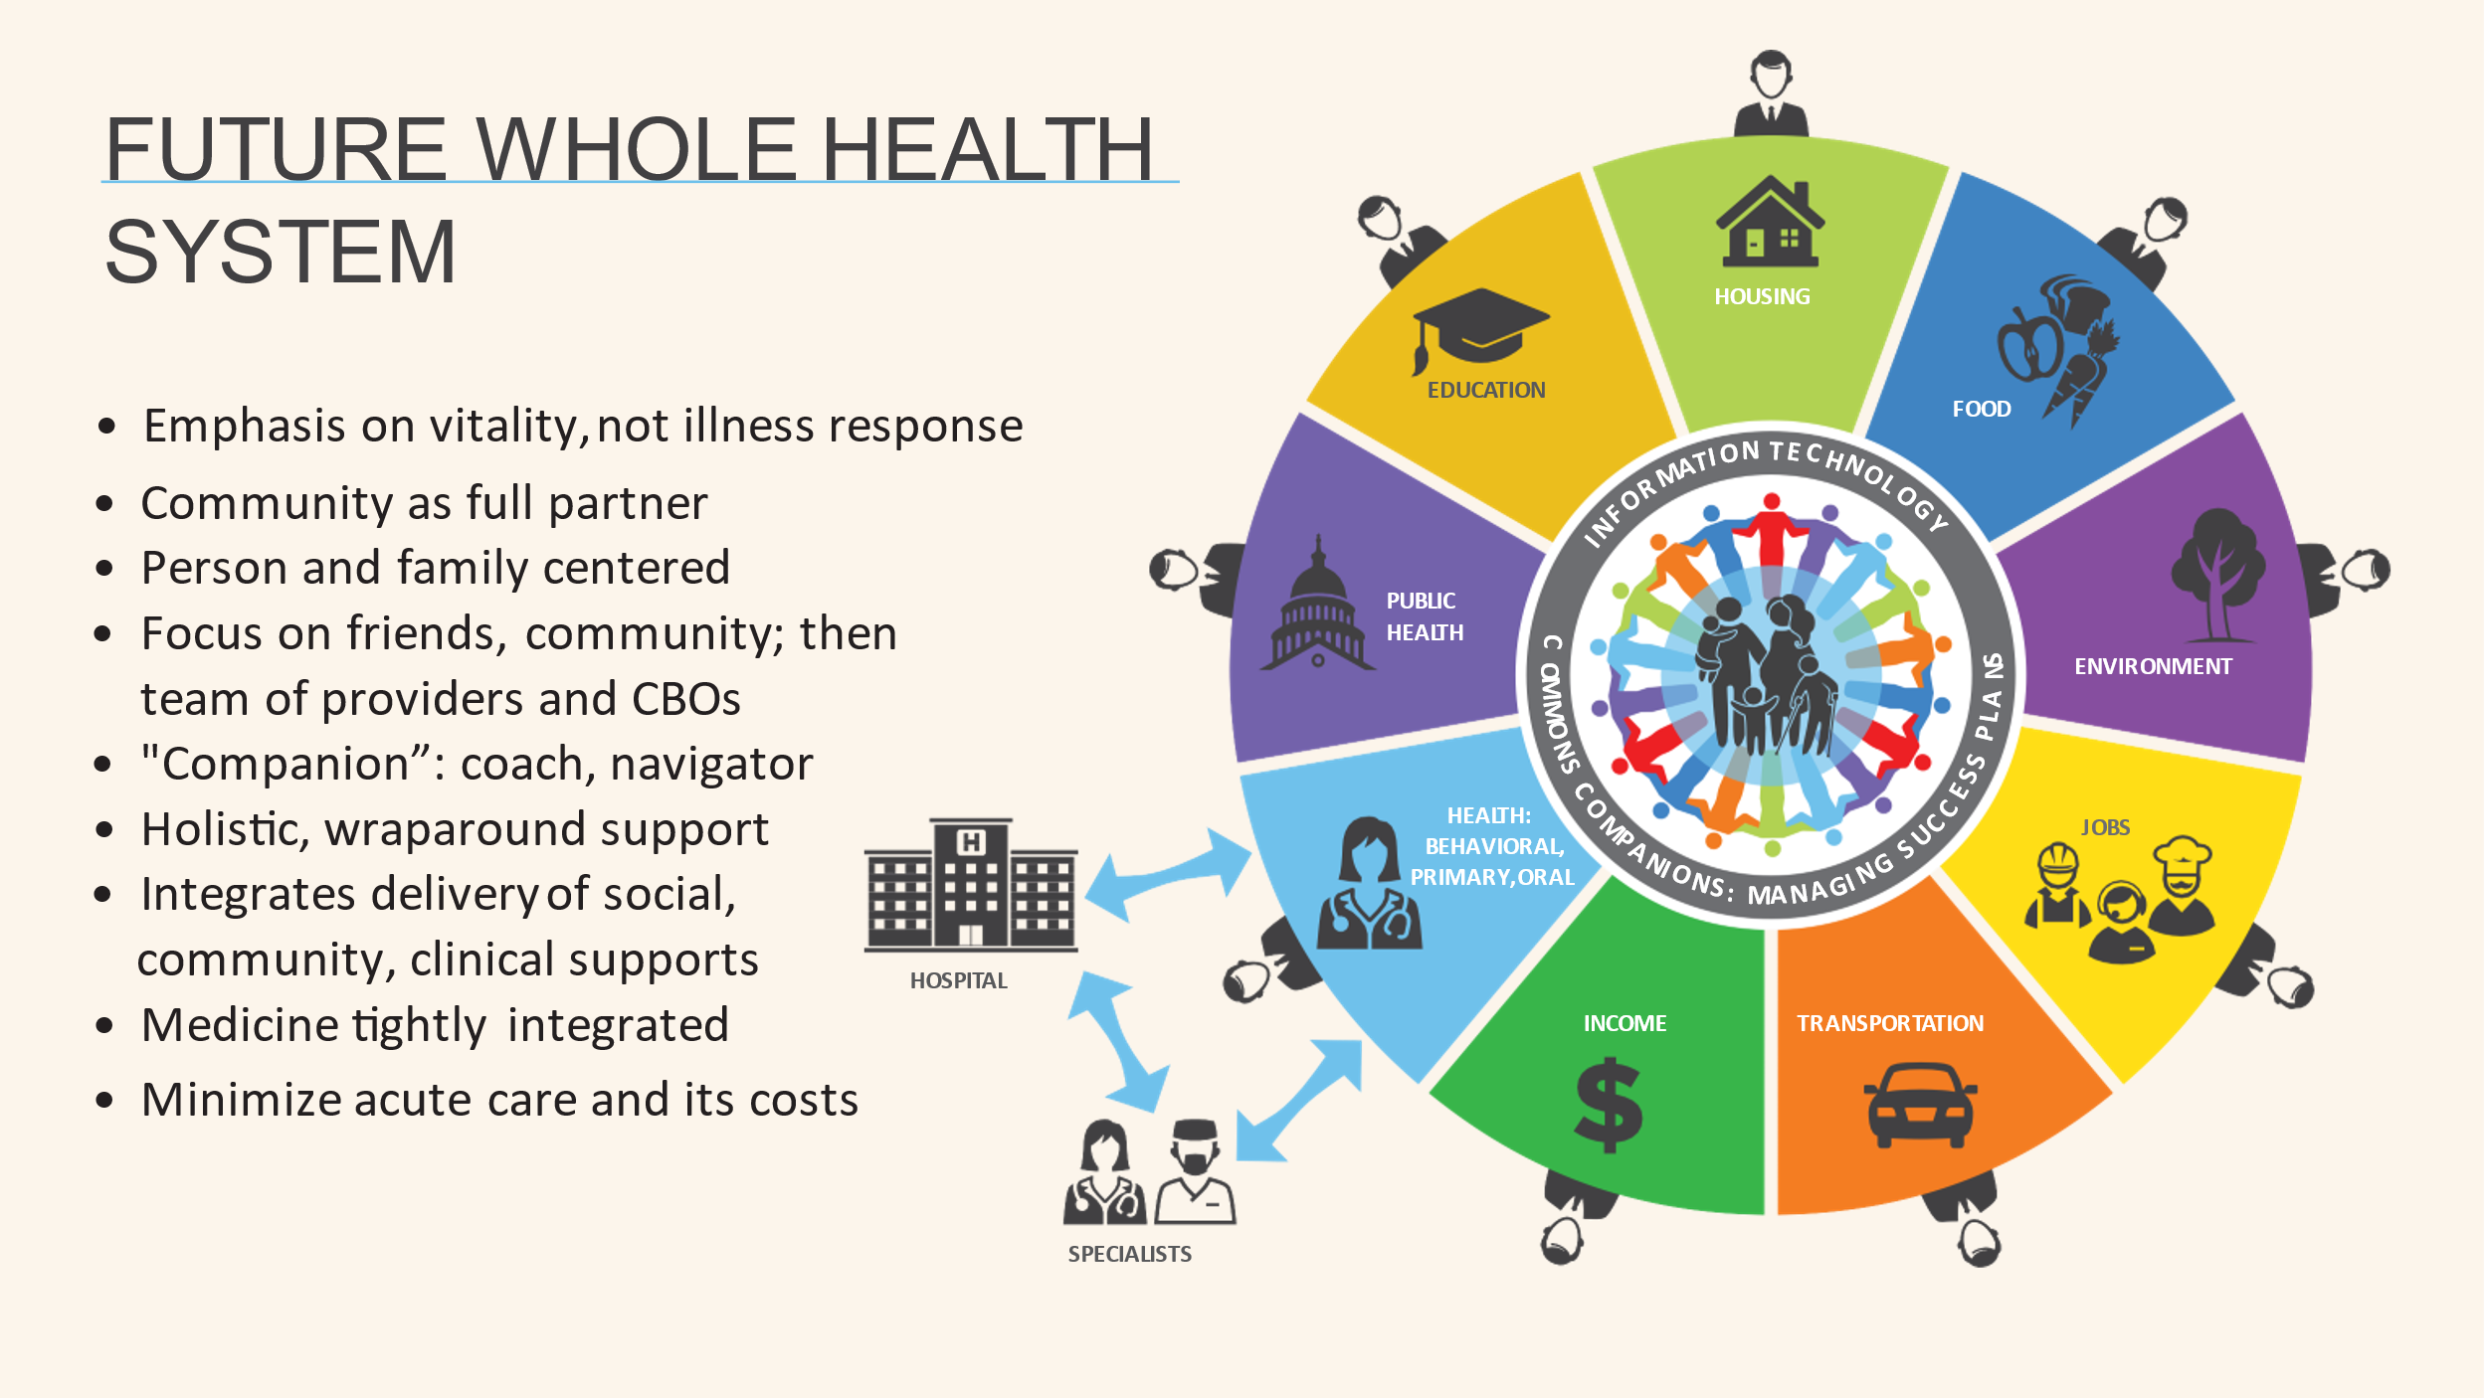
Panel 1 of Figure 4 shows this collaboration on a timeline. A collaborative of multiple providers devotes resources to support the individual or family. There are some shared expenses for developing and managing the individualized programs for vulnerable people and families, both initially and over time, as shown in Panels 1 and 2 of Figure 4. This is managed through a collaborative community structure, a “Commons”. Of course, there will be specialized clinical services as shown in the lower left of Figure 3, but they will be focused on those most in need, and closely coordinated with primary care. Acute care will be a last resort.
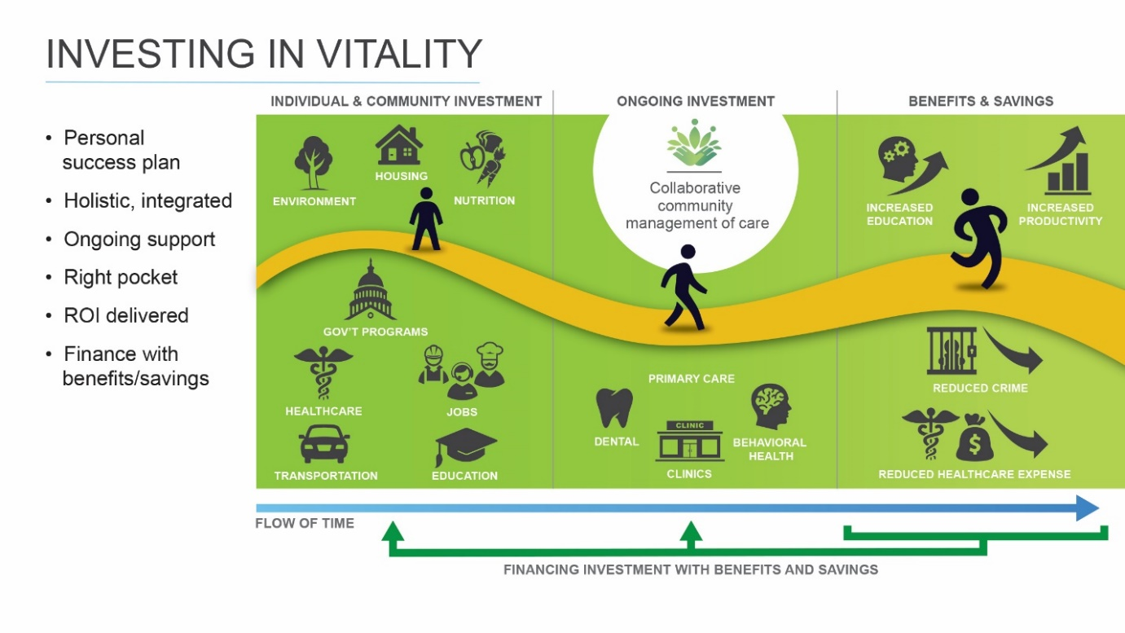
Figure 4.
The Benefits and Savings of Thriving
If this person/family-centered program is successful, the suffering of that person and their family will be reduced, and they will begin to thrive. Over time, a series of benefits will accrue to them (or become highly predictable for later in the future). Upside benefits and savings will also begin to appear for organizations, public and private, which interact with them (“Leg 2”), as shown in the final panel of Figure 4. Those benefits will appear at different times, to different organizations, and in different amounts. We could divide these benefits into two major categories: medical and nonmedical. In each case, some will be tangible (measurable and collectible, e.g., savings to corrections budget, Medicaid) and others less or intangible (or uncollectible, e.g., students learning better).
Medical benefits. The person and her family will benefit from vitality. They and those who pay some or all their medical bills will save from people being healthier with resulting reduced amounts being spent on specialists and acute health care (reducing the 87-91 cents of every health dollar spent on those). These include Medicaid, Medicare, private insurance, and often employers who self-insure for health.
Non-medical benefits. Creating vital human beings will produce higher levels of educational success, happiness, and income for the individual and family. Society will also benefit in nonmedical ways from savings by various social service agencies that support troubled or needy citizens, disability programs, reduced crime, and reduced use of jails. Employers and the broader economy will benefit from higher productivity. Some of these benefits could occur very quickly; some take a decade or two to emerge. Most can be measured or accurately predicted; some are more diffuse.
Critically, the benefits are accruing to different organizations than the ones providing the primary care and upstream services. This is called the “wrong pocket” problem.
We need to identify the specific beneficiary organizations and create a sophisticated adaptive system dynamics model that predicts the timing and the amount of the medical and nonmedical benefits that emerge from this program (and refine that model over time to make it as efficient and accurate as possible). Such a model could come to accurately estimate the synergistic benefits of holistic supports that are entirely ignored today.
Investing in Thriving
So, where does the initial investment to create this virtuous investment cycle originate? First, those who advocate for more investment in primary care and social services tend to focus on Medicaid and Medicare – as if they were the only beneficiaries. They are not, so we have a “free rider” problem. Other organizations’ budgets will benefit from people thriving, not just theirs. It is asking a great deal – too much in my view – to expect anyone of the governmental beneficiaries (federal, state, and local) to organize a common front, much less include the non-government beneficiaries. It is not part of their mission to convene the leaders of otherwise unrelated programs to recruit more investor participants to help marginalized populations to thrive.
It is further asking too much to expect these organizations to become long-term investors in thriving, i.e., take the risk that positive outcomes will not be achieved. Medicaid and Medicare are set up as reimbursement organizations, not risk-taking, longer-term investors. Taking medium and long-term financial risk is typically also not in the profile of primary care and social service call/human service organizations and charities.
This is why we need to add a new participant to the mix: an investment partner or collection of partners – the “Leg 3” we first met in the Denver example. Private investors are used to putting capital at risk for longer-term returns. This financial partner (“Leg 3”) should negotiate (or help the Commons/the provider group) with the range of beneficiaries to obtain a portion of those predicted savings/benefits, when and if they occur. What percentage of the savings/benefits would the payor/beneficiary organizations pay if positive outcomes were achieved? This percentage should be substantially higher if we remove the element of risk, by only requiring payment if the thriving goals are achieved (i.e., a “pay for success” model). Government should be willing to pay a higher percentage of those savings than the private sector, because they should place value on the benefits that accrue to individuals and the society as a whole, not just to agency budgets.
The investment partner would then commit its own capital to fund the collaborative person-centered support program described in Figures 2, 3, and 4, being repaid and profiting over time as the benefits are achieved. The investment could be a mix of private and public capital; different tranches could be created to reflect different levels of risk of repayment, with potential returns reflective of the risk. Until there is more experience with this comprehensive approach, we can expect that the riskier tranches of investment will need to be funded by parties interested in helping test out the model, if not purely charitable sources. Longer-term, it may be that the tranche of investment subjected to the most risk of repayment will need to be viewed the way we view public education or public infrastructure: i.e., we know society benefits; we do not need to see a specific ROI.
But this is not happening around the country. Why not?
Challenge 1: Wrong Pocket. More investment needs to be made in a coordinated program of primary health care and upstream in various family support programs from housing to education to food to day care to early childhood development, depending on the needs of the vulnerable individual/family. If successful, the financial returns will appear downstream in savings to the payers of specialist and acute health care services, in increased productivity to employers, in social costs avoided (e.g., police, courts, incarceration, social welfare), and in overall community benefits. However, there is no current mechanism to share some, indeed any, of those downstream returns with the upstream actors who spent the money to create them – unless the returns are effectively in the same time frame. As we can clearly see from reviewing Figure 3 and comparing the left-hand side of Figure 4 to its right-hand side, the organizations expending the money to create well-being and the savings from it are not those that are receiving the benefits. Investment and return are not coming from and ending up in the same pocket. Moreover, there is no method to aggregate those benefits to create a single, “braided”, payment stream that can be properly allocated to the health and social service providers upfront and over time. Similarly, there is no way to collect and properly share the savings and benefits created, either with the investors or among the collaborating agencies. It would be silly and counterproductive to try to allocate specific benefits to specific interventions or their providers.
Challenge 2. Timing and amount of ROI in benefits and savings. As shown in Figure 4, the benefits accrue over periods of time, and some occur far in the future. This is quite unlike the current health system where payment occurs contemporaneously with the medical service provided. Payers for health services do not think like investors in businesses -- where it is assumed that returns are uncertain and will be in the future. Public and private medical payors are beginning to recognize the importance of the social determinants of health, but their investment time horizons continue to be short and their scope relatively narrow. Crucially, it is well established that they can and will share savings in medical costs. However, the evidence base and practice to date is limited to specific, single interventions.
Some entrepreneurs are already taking advantage of the “low hanging fruit” in SDoH. For example, Parkland Memorial Hospital in Dallas invented, developed, and spun off the software solution it developed to improve its coordination with the social service providers surrounding it in Dallas. The resulting software company, Pieces Technology, provides a more robust referral and two-way communications interaction between clinical providers and CBOs when the clinical provider identifies the need for a social service. Pieces is confident of its ability to shave half a day off an average five-day hospital admission for the 80% of Medicaid patients that they estimate could be affected by SDoH interventions. With an average $3100 per day hospitalization cost, Pieces’ business model in selling to hospitals is obvious. Other groups like Aunt Bertha and UniteUs are pursuing similar strategies, charging medical systems while offering their applications to CBOs and others in the communities of those medical systems at no charge.
Challenge 3. Collective Funding. Medicaid and Medicare would probably be the largest single beneficiaries of this program, but they would clearly not be the only ones. Other beneficiary agencies and organizations should be approached as potential investors, and/or payors for success to avoid a free rider problem (organizations who do not contribute, but benefit). Yet, there is no “lead beneficiary agency” which has the capability or responsibility to organize the various public and private beneficiaries of thriving, as shown in Figure 4. If we had such a lead agency, it would negotiate with the providers of these health and well-being services shown in Figures 3 and 4 to deliver a specific set of outcomes, negotiate with the downstream beneficiaries a specific amount they would pay for the benefits they get when and if received, and/or recruit public and private investors.
In an excellent paper “Social Determinants as Public Goods”, Len Nichols and Lauren Taylor suggest a creative approach to finding and extracting as much upstream investment from public and charitable sources as possible, applying the “Vickrey-Clarke-Groves” auction mechanism to minimize the free rider problem. Their suggested approach calls for a trusted intermediary to be this “lead agency.” In their proposal the trusted intermediary (e.g., a local foundation) gathers all the potential health payor beneficiaries of primary care/SDoH investment, selects one or more interventions for which there is strong evidence of ROI, generates “bids” from each beneficiary, hires a contractor to manage the intervention, and then has a credible expert measure the results.
This solves the free rider problem, but because the payors are asked to be the investors but are limited to “Leg 2” (current payors), it does not extend the ROI time horizon beyond a year or two. It is further limited to health payors, and single interventions where there is strong evidence of ROI.
A suggested solution.
Investments in a unified, collaborative program of advanced primary health care and social services made today, and supported over time, should produce benefits of relatively certain sizes to different parties at different times in the future. Rather than seeing the above challenges only as a complex health and social service puzzle and expecting people expert in those fields to create answers, let us treat them as a finance challenge. Let us seek out finance experts who make a living every day bridging financial gaps and challenges and bring them to the table to apply their skills to designing a new system to help people thrive, including the approach that “pay for success” advocates are beginning to use in social service and environmental fields. In other words, let us intentionally create “Leg 3”, and the systems and incentives to make it work.
What if a group of community leaders, public health, and primary health care and social service providers (“Leg 1”) partnered with an expert financial organization (“Leg 3”) in such an effort? One or the providers could serve as the “general partner” (or the group could create a new formal partnership that we are calling a “Commons”, controlled by a board representing community leaders, and the three relevant provider sectors. The providers would have significant control over the quality of the collaborative intervention program, and thus have major control over outcomes. They would have extensive knowledge of the costs and returns of the program. The financial partner would have the expertise to negotiate payment agreements with the beneficiaries when and if success is achieved (“Leg 2”). Most of these beneficiaries are well-known to the providers. The Leg 2 investors have the access to funding to make the initial and on-going investments in the primary care and social service program, and the ability to absorb the level of risk that the clinical and social services providers choose not to accept. The providers and their financial partner could then agree among themselves on the allocation of risk and benefit.
Both the investors and the provider group might agree that giving the Members a financial stake in the outcome, some share of the potential benefits, would improve the chances of success. One key topic not discussed so far in this paper is the connection, if any, between finances and the actions of the Members. Positive involvement by Member families and individuals in their success plans is essential to their individual success and the success of the collective. There is a rich literature on behavior change, exploring the relative benefits of positive and negative incentives, including financial ones. Therefore, investors might want to know what stake the Members have in the outcome, beyond their individual health. One area worth exploring is treating the Commons at least partially as a cooperative, and having the Members share in the financial benefits that their actions help create under preagreed circumstances and/or outcomes. This would give Members both individual and collective incentives, reasons to encourage others in the Commons to act in healthy ways. Properly designed, it might also be a part of establishing a new status for the participating Members, a new self-image, which is thought to be an important element of behavior change. We already conceive of the Commons model as a locally controlled, non-profit organization. Incentives of these kinds would build on that community ownership and control.
Certainly not all the benefits of these upstream investments can be captured downstream within this suggested mechanism. Many of the benefits will accrue to individuals in better lives, less out-of-pocket expenses, and higher income – a highly desirable result. Some benefits are too long-term or diffuse to specifically capture this way. Dr. Glen Mays of the Colorado School of Public Health has suggested that we look at a portion of the investment that creates these benefits the same way we think of investment in public roads, public education, and other social goods. Perhaps we could garner broad charitable or government investment on top of privately funded pay for success schemes to take the riskiest tranche.
The acid test is whether there are enough upside benefits and downside savings from enough definable agencies and organizations to fund (1) the new integrated well-being program, and (2) the needed financial costs and profits of the “Leg 3” financial investors (private, public, or both). The extraordinary imbalance of investment in far more expensive acute and specialist care (the “87-91 cents pot”), and the wide array of studies showing significant ROI from specific upstream/prevention investments should create optimism.
What is the best way to organize Leg 3, to bring investment to the table? To date, the primary focus has been on public or foundation money. There is interest from the Federal Government. Yet there are far larger pools of private capital which could move far faster, with great impact, when a reasonable chance of profit can be demonstrated. Perhaps the best place to start would be those with an announced interest in “social impact” investing and foundations interested in “program related investments” (seeking a good chance of getting back some or all their principal). One can envision stratifying investment risk with private money taking the least risk, followed by “program related investments” by foundations using their balance sheets to invest in a riskier tier. If more investment is needed, once the data are compelling, we could look to government to add more funds in the spirit of public infrastructure and public education as discussed previously.
The legal pathways for compensating parties with a portion of clinical cost savings by government payors are becoming well established (in sharp contrast to the nascent policies allowing investing Medicare and Medicaid funds in social determinants). Consider the growth of Accountable Care Organizations with “shared savings contracts”. Stage IV ACOs are signing contracts across the country to share in the savings enjoyed by Medicare due to the ACOs providing better care management. Similarly, Managed Care Organizations are undertaking capitated contracts for management of Medicaid patients in many states, taking on risk and reward from controlling overall health costs.
Conclusion -- So, what is stopping us from doing this right now?
We are just emerging from the crucible of the pandemic. It underlined the enormous weaknesses and shocking disparities of our current systems. It is hard to imagine a stronger demonstration of the need for significant change. The federal government’s reaction in 2021 has provided substantial resources to state and local governments to respond to health challenges. This is a particularly exciting and opportune time to try new approaches. Indeed, it is hard to imagine a better time.
If we do not change what we pay for, we will not get a different result. Let us explore this new approach based on investing to achieve vitality, thriving. Let us design a new system rewarding achieving new metrics of vitality/thriving. This would create a new “Story of the River” that looks like Figure 5: increased upstream investment, enhanced primary care, significantly reduced serious illness, better managed chronic conditions, focusing specialists and acute care on those in real need who we could not keep from getting ill: better wellbeing for less overall health and social failure costs.
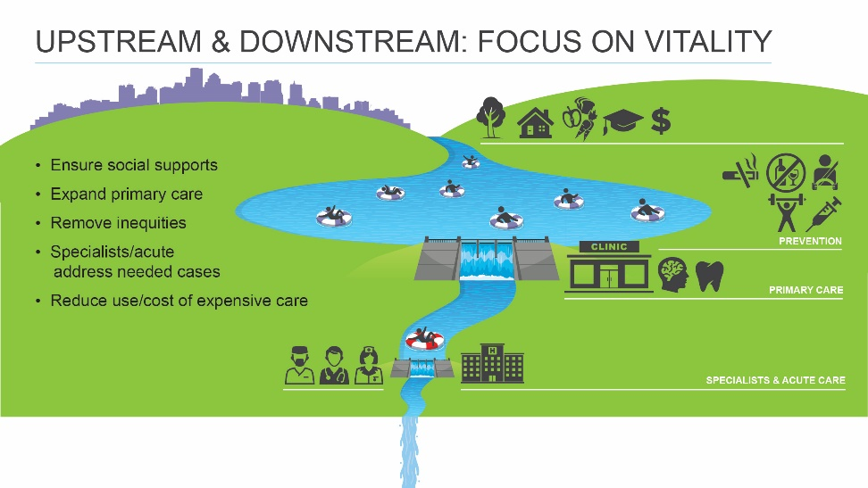
Figure 5.
What is holding us back? Why are we not creating new systems focused holistically on thriving, rather than adding one or more SDoH interventions to primary care? In a word, data.
We do not know enough. We know a lot about the ROI of several individual upstream investments. We do not know the cost and impact on holistic well-being of various packages of integrated health and social service interventions, much less the amount, beneficiary organization, and timing of benefits those will produce. We do not have a complete picture, particularly of the synergies that should emerge from integrated programs. Hunter et al note: “The evidence documenting ways that investment returns are captured by different sectors is similarly limited.” One critical goal is to develop that data, particularly about the impact of integrated, comprehensive systems.
We do not have to wait 30 years to collect the necessary data. Within a reasonable amount of time we should be able to show data clearly pointing to the right outcomes and their size. At that point, the beneficiaries will begin to see their self interest in making agreements with us or our “Leg 3 financial partners”, if and when we are successful. Thus, the core problem we face now is the absence of knowledge developed from real world experience in the field with new comprehensive systems. Until we have the data, COVID response funding and ideas like “Wellness Funds” can be the bridge.
Let us design and implement comprehensive collective impact systems focused on expanded primary care integrated with upstream social services and influencers and operate them AS IF we were on a pay for success model. Let us seek and use COVID response funds and philanthropic investment to substitute initially for the at-risk investors who will follow or find socially conscious entrepreneurs who will help create a market. This will give us real-world experience and the associated data so we can improve the lives of the disadvantaged, and so financiers can make money investing in us to do so. If we are successful in “de-risking” this approach, it will be much easier for government funders to adjust to paying for vitality.

This is a work in progress that has benefited greatly from critiques and additions by friends and colleagues. I would be grateful for any criticisms and suggestions you may have. david.aylward@cuanschutz.edu

See “Well”, Dr. Sandro Galea, Dean of Boston University School of Public Health, 2019, for an up to date and accessible review of how and why our investment priorities are backwards, what creates health. “The Health Gap” by Sir Michael Marmot (2017) is a definitive review of the causes of illness and health, and the reasons for the gross disparities in outcomes depending on income, race, and similar factors.
While the US spends at least two times (and usually far more) per capita on health than all other developed countries, it spends about 90 cents of each health dollar on social services, i.e., the social determinants of health. In contrast, other developed countries spend on average $2 on social services for each health dollar spent. Combining the two, the US is in the middle in spending, although with far more ill health and resultant suffering due to our predominating investment downstream, in acute and specialist care, rather than in primary care. States with a higher ratio of social to health spending had better outcomes for adult obesity, asthma, and other health indicators (Bradley, Canavan, Rogan et al., 2016).
My definition of “primary care” is the integrated offering of behavioral, physical, and oral health services.
See J. Mac McCullough, “The Return on Investment of Public Health System Spending,” Academy Health, 2018. See also James Hickman, sounding the alarm about the huge future societal costs if we do not invest to address prevent and treat Adverse Childhood Events early. See https://www.hickmanstrategies.com/news.
I am happy to share my embellishment and extension of the Story or Parable of the River.
https://www.cpr.org/show-segment/can-private-money-help-denvers-homeless/
;https://www.enterprisecommunity.org/news-and-events/news-releases/sanderson-apartments-employs-trauma-informed-design
https://coloradosun.com/2021/11/19/denver-social-impact-bond-expands/ “After the program met its goals, the city paid investors $9.6 million — $4.5 million in housing stability payments, $5.1 million in jail diversionary payments, plus $1 million for the project’s success. Investors agreed to share a portion of the $1 million payment with the two main service providers: The Colorado Coalition for the Homeless and Mental Health Center of Denver.”
A range of studies show the downstream health benefits and cost savings of upstream investments in a wide array of interventions from prevention to food to housing to transportation. See Galeo, op.cit. See fns 1 and 4. The Washington State Institute for Public Policy has created a useful resource providing cost, effectiveness and ROI evidence on many health and social determinants interventions. www.wsipp.wa.gov. The Commonwealth Fund has financed the creation of an “ROI Calculator to Address SDoH” that brings this data to a single tool, although it is limited to single interventions. https://www.commonwealthfund.org/roi-calculator The evidence is not all on one side. A recent RCT published in NEJM found that a clinically focused program in Camden, New Jersey addressing the most expensive Medicaid patients did not produce fewer hospitalizations in a three-year time frame than those without the intervention. But reduced hospital visits is a narrow metric; the level of social supports provided to these high needs/high use patients in the program was unclear. The primary focus of the program seemed to be medical, not an integrated plan with social services. https://www.nejm.org/doi/full/10.1056/NEJMsa1906848
See, e.g., Dawn Alley et al, “Payment Innovations to Drive Improvements in Pediatric Care—The Integrated Care for Kids Model”, JAMA Pediatrics. Published online, June 3, 2019. Alley is a senior official at CMMI. https://innovation.cms.gov/innovation-models/integrated-care-for-kids-model#:~:text=The%20Integrated%20Care%20for%20Kids,of%20behavioral%20and%20physical%20health
Funders Forum on Accountable Health has created an extremely useful national database of these and similar projects. https://accountablehealth.gwu.edu/
The lessons of Collective Impact hold much promise -- applied here to comprehensive family support.
The behavior of the Member individuals and families is critical in the outcomes. Thriving requires their commitment to implementing the success plan; it is not simply care that can be provided to them. See discussion of the Member role in finance below.
We will NOT have to wait 10-20 years to know all the benefits that such a program will produce. There is already extensive evidence on specific outcomes that will be produced in the future if certain milestones (positive and negative) are achieved. For example, we know the future health savings of controlling blood sugar levels. The number of untreated Adverse Childhood Experiences (ACE) are highly predictive of future illness.
Success based payments would not have to only occur after a final successful outcome a long time in the future. Progress payments could be based on achievement of milestones indicating the program is on a successful path, e.g., proper birthweight babies, reading at third grade level at third grade, blood pressure controlled, appropriate blood sugar levels, absence of ACEs (or effective treatment of them), etc.
If the returns come in the same time frame, financing is easy; it is the equivalent of the dreaded fee-for-service approach on the medical side from which everyone claims they want to flee. Thus, we see people arguing for funding taxicab rides to doctors’ appointments, or funding housing for homeless people who are in the ER multiple times a month.
Both human beings and the service models that support the creation of well-being are complex, adaptive systems. Multiple inputs are mixed to create multiple mixed outputs. We are not looking at a collection of specific outputs caused by separate interventions. Thus, both the program to create health/well-being and its financing must be approached holistically using a complex adaptive system dynamics model to predict and track outcomes.
Note that all of these treat specific social needs in singular one-off transactions, rather than the wrap around, longitudinal approach to holistic, integrated person/family support we favor, and we see somewhat in the CMMI InCK program.
I have seen rough estimates that two thirds of the ROI from such programs would be in medical cost savings. One advantage to starting this approach with lower income people, with Medicaid and Medicare as the primary medical payors, is that people shifting between private insurers is less of a challenge to collecting on the returns of up-front investment.
This creates a free rider problem. If an agency with significant downstream benefits chooses to invest to create those benefits, it will be paying for benefits for other organizations that have not contributed. A “Leg 3” financial organization cannot stop free riding, but it has a powerful incentive to try.
Health Affairs, 2018 https://www.healthaffairs.org/doi/full/10.1377/hlthaff.2018.0039
See, e.g., Quantified Ventures. https://www.quantifiedventures.com/
Strong primary health care providers may be in the best position to organize such efforts (“Leg 1” and a part of “Leg 3”) – and they have an incentive to do so, unlike healthcare organizations the business models of which are dependent on sick people who need extensive specialist and/or acute care.
See, e.g., Hoskins et al, “Acceptability of financial incentives for health-related behavior change: An updated systematic review”, Preventive Medicine 2019 Medicinehttps://www.sciencedirect.com/science/article/pii/S0091743519302385?casa_token=XRDY0pyv7-4AAAAA:omWmR-UvQvmMioCSAJh5cMN601pV9jdu9cZ2TEShnDcDTVbe-PWOEZXvSHg8VK1FRe0H-vN_2SA
It may be worth reflecting on the broad experience with partial employee ownership of companies in the last few decades of the 20th century. I was the Chairman of an employee-owned timber and wood products company in the 1990s.
I encountered a successful example of this thinking in rural western Kenya where about 30 financial and health cooperatives of mostly female farmers competed aggressively with each other in managing blood pressure and glucose levels for monthly cash prizes within each group and between the groups; these groups were initially organized around micro-lending, and added the additional focus on well-being.
See, e.g., Caldwell et al., “Harnessing centered identity transformation to reduce executive function burden for maintenance of health behaviour change: the Maintain IT model”, Health Psychology Review, 2018.
The Morehouse Model for achieving community engagement and health equity emphasizes the importance of community control.
Professor Mays notes we make these investments to create an accepted societal benefit, which does not need to have a specifically defined time or amount of ROI.
The Nichols and Taylor paper of 2018 suggests the creation of a trusted local body, presumably a non-profit, to bridge the gaps between Legs 1 and 2, at least for SDoH interventions where ROI data is already established. https://www.healthaffairs.org/doi/10.1377/hlthaff.2018.0039
The Social Impact Partnerships to Pay for Results Act (SIPPRA), which was signed into law in February of 2018, provides for the federal government paying for a project, contingent upon project outcomes being met and validated by an independent evaluator. If the desired objectives are not achieved, investors receive neither a return nor repayment of principal.
I do not mean to minimize potential policy changes required to shift to this kind of the system. Presumably, a Section 1115 waiver would be required for Medicaid. The relevant parties are much more likely to undertake significant policy change if we can demonstrate the benefits discussed herein.
There are an array of studies showing specific ROI for specific prevention and SDoH investments. Dr. Victor Tabbush developed an “ROI Calculator” for exactly this purpose. The refinement and expansion of this valuable tool has been funded by the Commonwealth Fund. However, it is limited to calculating the ROI of single interventions, rather than the more complex, holistic person-centered systems that we seek to create (and from which we can expect synergistic results). https://www.commonwealthfund.org/roi-calculator
Hunter, E.L., Edmunds, M., et al. “How Evidence Drives Policy Change: A Study of Return on Investment in Public Health and Multi-Sector Collaborations”. Academy Health 2018.
For example, experts in diabetes can predict the medical savings per person if A1c measurements are lowered by a certain amount. Dr. David Olds has used RCTs to prove long term benefits in a variety of areas from the Nurse Family Partnership he developed decades ago and has studied in many environments. https://www.nursefamilypartnership.org/about/proven-results/evidence-of-effectiveness/. If we bring the complex adaptive models from systems science into healthcare, as we should, we can develop models that combine what we know and what we predict at the beginning, correcting our predictions with real data as we go along, until we have enough data to convince the investors.
I suggest focusing pilots of the new model on two limited target populations at the two ends of lifespan as the proof point: (1) families with young children, and (2) seniors with multiple non-acute chronic conditions.
There is a fascinating and critical inquiry here that needs to be undertaken, applying the relatively new social investment field of “Pay for Success” to health. The Denver project discussed is an example. See, e.g. https://pfs.urban.org/; https://www.milbank.org/quarterly/articles/pay-success-financing-home-based-multicomponent-childhood-asthma-interventions-modeling-results-detroit-medicaid-population/. See also https://www.quantifiedventures.com

